User Acceptance Testing (UAT) Template
Team ID | SWTID-2026-7861
Project Name | Auto Ticket Classification using Flow Designer
Maximum Marks | 4 Marks

Project Overview:
Project Name: Auto Ticket Classification using Flow Designer
Project Description: A ServiceNow Flow Designer solution that automatically classifies school IT support tickets using keywords in the Short Description/Description and assigns the appropriate Category and Subcategory.
Project Version: 1.0
Testing Period: 28 September 2026 to 01 October 2026
Testing Scope:
Testing Scope: Automatic classification, Category/Subcategory dependency, keyword-based Flow Designer logic, ticket data capture, and automated email notification.
User Stories / Requirements Tested: Wi-Fi classification, Projector classification, Password/Login classification, Slow/Hanging computer classification, and caller email notification.
Testing Environment:
URL/Location: ServiceNow instance – Incident Workflow table and Flow Designer
Credentials (if required): Not included in the project documentation.
Test Cases:
Test Case ID | Test Scenario | Test Steps | Expected Result | Actual Result | Pass/Fail
TC-001 | Wi-Fi ticket automatic classification | 1. Enter Caller Name.  2. Enter Short Description: “WiFi not working in library”.  3. Save and reload the form. | Category = Network; Subcategory = WiFi; confirmation email sent to caller. | Pass – Category and Subcategory were filled automatically and email was sent.  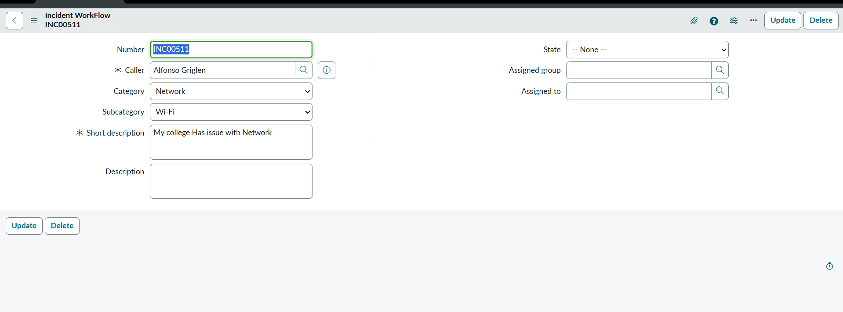 | Pass
TC-002 | Projector ticket automatic classification | 1. Enter Caller Name.  2. Enter Short Description: “Projector not turning on”.  3. Save and reload the form. | Category = Hardware; Subcategory = Projector; confirmation email sent to caller. | Pass – Category and Subcategory were filled automatically and email was sent.  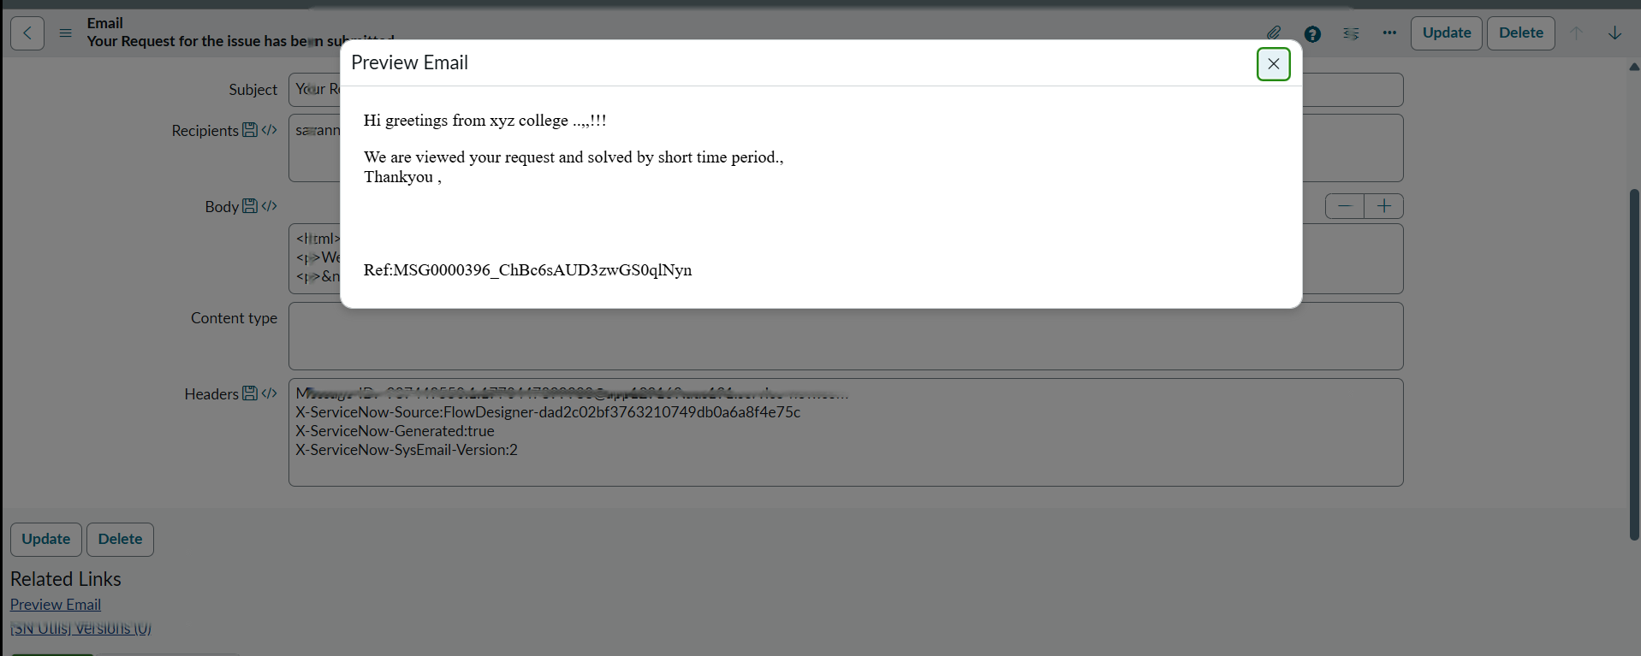 | Pass

Bug Tracking:
Bug ID | Bug Description | Steps to reproduce | Severity | Status | Additional feedback
BG-001 | No bug identified in the documented UAT test scenarios. | Not applicable. | None | Closed | No open issue documented in the supplied project report.

Sign-off:
Tester Name: Keerthana K (Team Leader)
Date: 01 October 2026
Notes:
- Ensure that all test cases cover both positive and negative scenarios.
- Tester feedback: documented scenarios produced the expected automated classification and notification results.
- Bug tracking: no open bug is documented for the supplied test scenarios.
- Sign-off is provided by the project team tester before deployment.

